HCI - HappyTravel

| Sonali Atram  MIS Student  IU Bloomington  satram@iu.edu |  | Abu Saleh Md Noman  PhD Student  IU Bloomington  amdnoman@indiana.edu |
| --- | --- | --- |

# ABSTRACT

In the last ten years, the perspective of tourism industry and the way people travel has been revolutionized. The advent of the Internet and access of the majority of the population to new information technologies has generated a significant change in international tourist patterns and engendered new behavior. "Travel, Tourism and Technology": these three terms has become interrelated and indispensable in modern era. Clearly technology is becoming a major source to serve the needs of travelers, companies etc.. Thus, it is high time to analyze what travelers want, how their decisions are influenced based on these technologies, what kind of experience they want to get and design or adapt new technologies meeting their requirements. In this project, understanding how travelers behave is of critical importance to us because it has evolved radically over the years. We wanted to comprehensively analyze the influence of technology (websites, mobile apps etc.) in the decision making of travelers. We also wanted to understand what kind of experience the travelers want to get and if it has any impact in deciding the place they want to visit. We interviewed travelers to learn and understand the thought process behind choosing a particular location to visit and its influencing factors. Based on the interview intentions for visits and the satisfaction rate, we created and sent couple of surveys out which resulted in 100 followed by 24 people responding. After that, we tried to provide a solution, *HappyTravel*, which fulfills their requirement and get a feedback from users.

## Keywords

Travel tourism; Data analysis; HappyTravel; Influences

# INTRODUCTION

The way we travel has changed immensely in last 10­-15 years. Latest travel search engines like Travelocity, Expedia and Tripadvisor make it easy to plan trips beforehand. Reviews by users for every travel destinations, hotels and places also give us confidence and makes us feel safe to visit the location we have never visited before. The application of technology prior to traveling and during travel has forced researchers to facilitate more user friendly technology for travelers around the globe. According to Think With Google's '5 Stages of Travel,' the average traveler visits about 22 travel-related sites prior to booking a vacation and 70 percent of business travelers will check into their flights and hotels via their mobile devices [7]. It is therefore of no wonder that technology and tourism are becoming closely intertwined.

Travelers nowadays frequently consult various travel planning websites and travel agencies. Although some of these services are fully-fledged, often they fail to provide a feasible solution meeting the demands of people. Also, it still has a less impact on where we travel. Other than planning and booking for flights and tickets, we are not sure how much personal impact it has on our decisions to travel to certain places. The existing technology in tourism business comes to little help in decision making of millions of travelers travelling every year. Thus, the research question for this project was ‘although travel tourism online industry makes it very easy to plan trips ahead of time and saves great deal of money doing so we wanted to see how much influence it really has on deciding where to go and what type of experiences to get.’

This motivated our choice of interview and survey questions to get some answers about how travelers arrange their activities and support their requirements accordingly with technology available today. We have analyzed traveler’s responses about existing systems and whether there is a need for more information. As we said earlier the main focus and motivation of *HappyTravel* project are:

* Understanding the influence of existing technology on travelers planning.
* Understanding the demand of travelers and find the correlation of this with their plans.
* Providing a prototype fulfilling their demands.
* Trying to overcome the drawbacks of existing technology (e.g. lack of family friendly travel planning media).

Incorporating the feedbacks from interviews and surveys that we conducted, we provided a wireframe of a webportal that is not fully developed. The rest of the paper describes the existing technology, research methods and instruments, data analysis and future directives.

**EXISTING TECHNOLOGY**

With the rapid growth of technology including websites, mobile apps, online travel agencies etc., modern travelers use tech­nology more than ever before. Recent study shows that the Internet has revolutionized the tourism industry more than any other factor in the last few decades. With access to the vast pool of information available online and information sharing among online travelers, an increasing number of travelers are seeking information via Internet prior to making any travel decisions.

Technology is helping people plan and travel in various ways. For example, “*the Mondrian Hotel in New York City's Soho neighborhood provides each of it’s guest an iPad in a room to use to order food, plan their travel and coordinate transportation. The Roadside America app helps travelers uncover hidden gems and roadside attractions during their road trips. Social networking campaigns like the one launched by Mayor Buckhorn in Tampa Bay, Florida, uses social media to engage tourists. What's more, photography innovations such as the Tamaggo 360 ­Imager allow consumers to capture their vacation experiences like never before*” [7]. Recent research shows these are the medias people find and share information: Internet websites, Search engines, Blogs, E-Mail, eNewsletters, List-serves, Wiki, iPods, Pod-casting, PDA, Wireless phones, GPS mapping, Laptops, Web-cams, Webinars, RSS feeds, Web-TV, GPS mapping, Online games, Social networking and personal sites.

Some websites and apps currently used are as follows:

|  |  |
| --- | --- |
| Website and/or App | Purpose |
| SeatGuru | Pick a good seat in flight |
| Points.com | Track your status |
| Worldmate Gold | Keep track of itinerary |
| Hipmunk | Stay at desired holiday location |
| Priceline | Cheap booking and deals |
| TripAdvisor | Get other travelers review |
| Flight+ | Track your flight |
| Google maps | Navigate the roads |
| Roadtrippers | Plan roadtrips |
| Expedia | Plan trip and booking in advance |

Table 1. Existing technology in use.

*Tripadvisor*

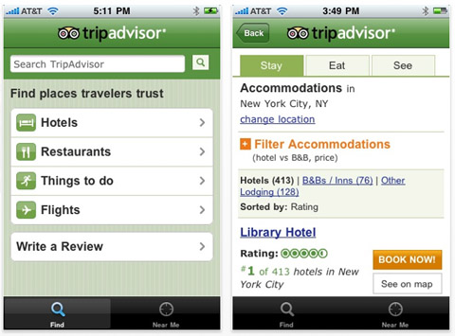

Figure 1: Tripadvisor mobile app

Tripadvisor is the largest travel online community available. It allows users to book flights, hotel, vacation rental etc.. It also allows travelers to review and compare prices, make 3-4 days travel plan, upload pictures and write forums.

*Expedia*

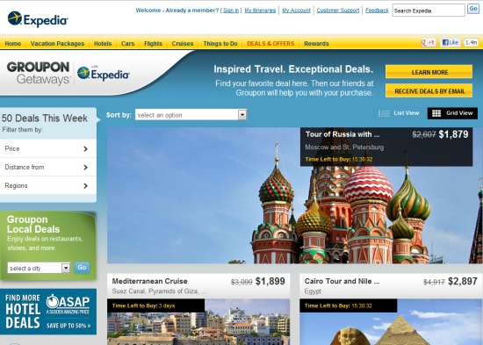

Figure 2: Expedia website

Expedia offers similar provisions as Tripadvisor. It has some additional features like Bundle deals, cruise booking etc.. Like Tripadvisor it also has mobile version.

*Google travel dashboard*

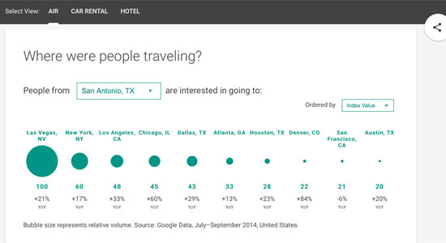

Figure 3: Travel Dashboard

Google travel dashboard has been the latest addition. It allows travelers to view the trend in car rental, air and hotel categories so that they can plan beforehand. It shows statistical data of where people are traveling, most popular itinerary, top searches, travel videos and much more.

*Roadtrippers*

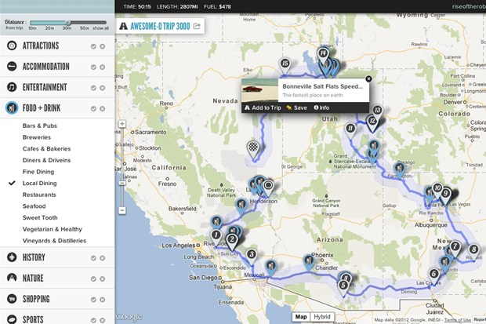

Figure 4: Roadtrippers map

Roadtrippers is another very popular service used by people interested in road trips across USA. It allows them set a source and destination with different checkbox options. As shown in Figure 4, it creates the map for the user and places some legends on the map depending on the selection (attraction, food & drink, points of interest, camping & RV, nightlife, shopping, sports etc.).

*Significant others*

* ‘CICtourGUNE’ features an intelligent platform that monitors, measures, analyzes and models the flows of visitors to the different destinations [8].
* ‘GESFOR THOFU’ has implemented a plan that aims to establish a model for the hotel of the future [8].
* 'Venice Connected' is another comprehensive management tool to monitor tourist flows in Venice [8].
* Google Maps, Gasbuddy, Triposo, Kayak are also popular among travelers.

# related works

We did not find a lot of previous work on this topic. Most of the previous works addressed how tourism can be flourished and its business aspect. The effect of social media in tourism destination were discussed in [1]. The use and impact of online travel reviews were analyzed by the authors in [2]. Social travel planning in enterprise was researched in [3].

A context aware electronic tourist guide is another novel approach in this regard [4]. The earliest work on developing a location-aware tourist guide was Cyberguide [5]. Another related work on tourist guides was conducted as part of the HIPS (Hyper-Interaction within Physical Space) project [6].

The experiences and practices of travelers were previously ignored in different tourism literature. Therefore there is a significant difficulty in understanding and designing tourism technologies which meets the demand of travelers. This motivated our choice of quantitative and qualitative methods to look in depth at how tourists arrange their activities and support their requirements accordingly with assistive technology.

**RESEARCH METHODS**

We used interviews and surveys as two main research methods for our project.

*Interviews*

We interviewed 20 travelers for our research purposes. Nature of each interview was open-ended. The subjects travel at least three to four times a year. Some of the travelers travel for business and family trips both. But, we concentrated on family vacations for this project’s purpose.

*Survey***:**

Based on the interview results and feedback we received from the travelers we created a survey using www.surveymonkey.com and posted it on the different social media platforms. We received 100 survey responses.



Figure 5: Survey

When looking at the data gathered we realized we did not include google as one of the technology used to plan the trip. We created the second survey using Google forms which included google this time and posted it on the same social platforms. This time we received 24 survey responses.

*Proposed family friendly travel search engine*

Based on the results and analysis of our interviews and surveys we have created a wireframe of family friendly search engine. This will be evaluated by the class and we will incorporate the feedback from the students to further change this prototype.

**PARTICIPANT RECRUITMENT**

Our target population was adults over the age of 18 who travel and are familiar with the online technologies available. Interviewees were mostly friends and colleagues who travel for business as well as for family vacations. Two different surveys were created and posted on the social media platforms and we received total of 124 responses. For the purpose of this research project we are going to use 24 responses we received in the second survey. Data analysis and future directives will include the feedback from the students about the wireframe we created for family travel search online.

**RESEARCH INSTRUMENTS**

In order to better understand the influences or lack of influences of existing travel search engines and technologies we conducted a comprehensive interview with family, colleagues and friends. In our research we interviewed 20 travelers. All the interviews were face-to-face and open-ended which gave us an added advantage of understanding traveler’s behavior even better. Based on the interviews survey questions were designed in a way that will help to answer our research question better.

The interview questions that led to the specific information included the following:

* Have you traveled recently?
* Was it for a business or a leisure?
* Did you travel with family, friends?
* Who made the planning?
* What did you use to plan your trip?
* How far in advance you planned it?
* How did you research about your travel destination?
* What websites/ search engines/online communities you have used to make the travel arrangements?
* Were you satisfied with the information you received?
* What type of experiences were you hoping to get with this vacation?
* Have you ever got influenced by web advertisements or recommendations to plan a trip?
* Is there anything you wish you had more information about before the travel?

Survey questions included the following:

* What is your age?
* Do you travel?
* What is the purpose of your travel?
* How did you research about your vacation destination?
* Have you ever been influenced by websites or advertisements on web to visit the place?
* When planning a vacation/travel how do you gather information about the place?
* When making travel arrangements which of the following do you use?
* Is there anything you would like to see online that will help you get more satisfying travel experience?

We decided to see the level of satisfaction among the travelers in pre-deployment and post-deployment phase and perform a quantitative analysis on that too. A paired t-test would come to help in this case since we took two observations on same set of sample.

**PROPOSED PROTOTYPE**

*HAPPY TRAVEL SEARCH ENGINE*

Based on our data analysis and research results we felt that there is a value added in researching more into providing support and technology for better family vacation planning. The prototype we created is a family friendly search engine.

In this age of “big data” the technology to grab the relevant data from multiple sources such as social media, blogs, forums, and text mining is already available. The focus of this prototype is on finding the information for family friendly locations and events based on the users search with the help of already existing technology like data mining, text mining from the available reliable resources.

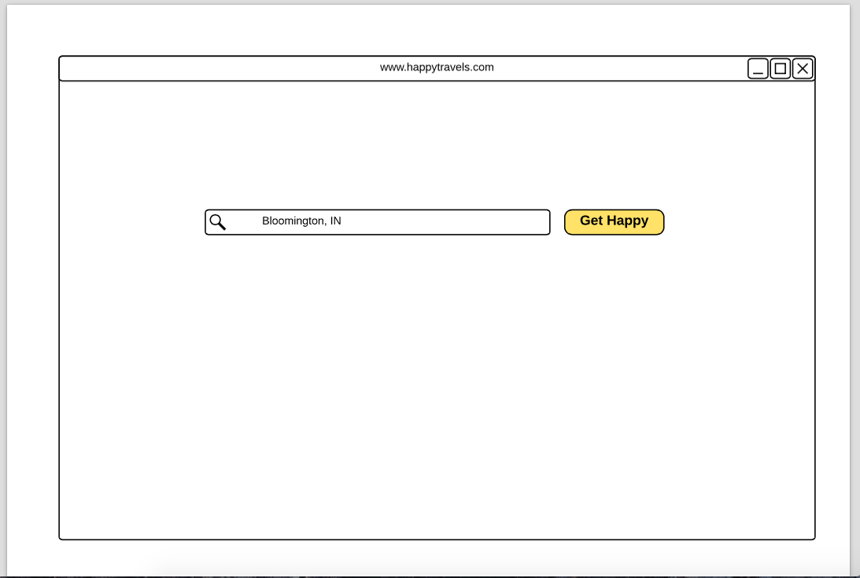

Figure 6: Home page of the website [www.happytravels.com](http://www.happytravels.com)

The design of this prototype is very easy to follow as it looks just like Yahoo or Google search engine and users are familiar with the process of searching. Once the user types in the destination and submits the query, a different page will open with all the information related to family travel events and destination.

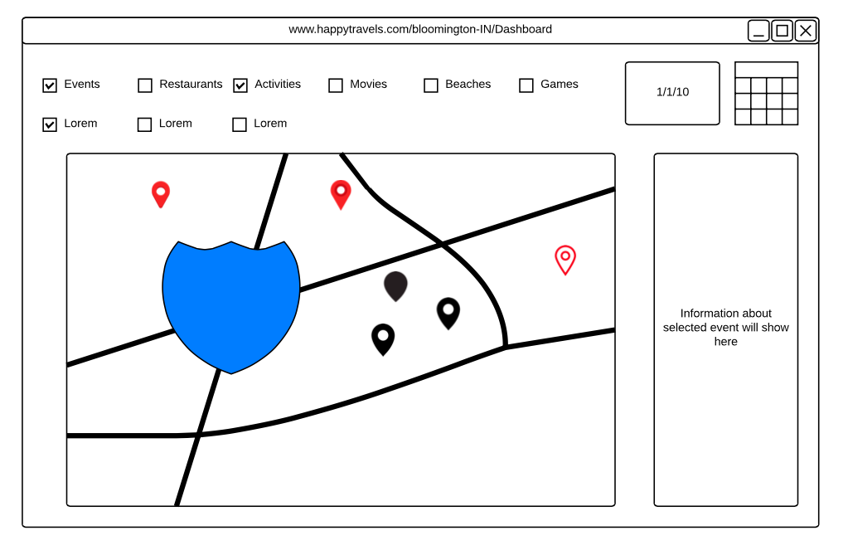

Figure 7: search result for the submitted travel destination

Users will be able to choose between the dates and the activities they are interested in. The google map will pin the locations and events search by the users. The right-hand side box will show more detailed information about the pinned event or activity chosen by user.

This search result gets its data from social media, blogs, forums and any other source of data which is helpful in finding the family friendly activities and events.

# DATA ANALYSIS

As we have said earlier, we conducted comprehensive face-to-face interviews with travelers and based on their responses we tried to figure out their needs which was reflected in a latter survey. We wanted to know if the existing technology is influencing their decision and what their expectations are. It turned out, what we thought initially was not reflected in our survey response. We performed quantitative analysis on the survey data.

*Quantitative analysis*

*t-test*

We performed a t-test for the paired dataset after we received feedback from people. One set of experimental unit was used (user of our prototype) and two different observations (level of satisfaction in scale of 5) were recorded. We wanted to see if the difference of mean is positive or negative.

The sample data was like:

|  |  |  |  |
| --- | --- | --- | --- |
| Respondent No. | Satisfaction level(after deployment) | Satisfaction level(before deployment) | Difference |
| 1 | 5 | 4 | 1 |
| 2 | 5 | 4 | 1 |
| 3 | 5 | 4 | 1 |
| 4 | 5 | 4 | 1 |
| 5 | 5 | 4 | 1 |
| 6 | 5 | 4 | 1 |
| 7 | 5 | 5 | 0 |
| 8 | 5 | 5 | 0 |
| 9 | 5 | 4 | 1 |
| 10 | 5 | 3 | 2 |
| 11 | 5 | 4 | 1 |
| 12 | 5 | 4 | 1 |
| 13 | 4 | 5 | -1 |
| 14 | 5 | 4 | 1 |
| 15 | 5 | 4 | 1 |
| 16 | 5 | 3 | 2 |
| 17 | 4 | 4 | 0 |
| 18 | 4 | 5 | -1 |
| 19 | 4 | 3 | 1 |
| 20 | 5 | 5 | 0 |
| 21 | 5 | 4 | 1 |
| 22 | 5 | 4 | 1 |
| 23 | 4 | 4 | 0 |
| 24 | 4 | 4 | 0 |

Table 2. Paired t-test.

The qqnorm plot for difference column was straight line so we could perform t-test.

Null hypothesis: mean difference≤0

Alternative hypothesis: mean difference >0

Where mean difference of sample is .833 and standard deviation is .564. t-statistics value is 7.229

p-value=1.16e-07 for degrees of freedom=23

Therefore, the null hypothesis can be rejected and we can say that the satisfaction level increased after using our prototype. Although the sample size was pretty small, the difference showed normal distribution.

*Qualitative analysis*

All interview responses were inspected together using a mixed-methods approach. We first analyzed the data for evidence of whether *TravelHappy* supported the needs of travelers. We used open coding and multi-phased affinity analysis to uncover emergent themes from the interview data. We then developed a coding scheme focused on traveler’s online experience. This coding scheme was cross-analyzed during discussions to validate and refine its categories and properties.

From the interview responses we tried to identify the concept of traveler’s online search and their experience. During the open-coding step, the codes that we ended up with were:

* Google search
* No influence of online ads
* Landmark
* Cultural experience
* Adventure
* Family vacation
* Tripadvisor
* Business trip
* Kayak, Orbit etc.
* Cheap deals
* Recommended by friends
* Mobile apps

Later in the axial coding step, we categorized them into further groups:

Subcategory 1: Technology

* Code: Google search
* Code: No influence of online ads
* Code: Tripadvisor
* Code: Kayak, Orbit etc.
* Code: Cheap deals
* Code: Mobile apps

Subcategory 2: Experience

* Code: Landmark
* Code: Cultural experience
* Code: Adventure
* Code: Family vacation
* Code: Both
* Code: Business trip

We coded each unit in excel file with concepts. We tried to get rid of the unnecessary codes and kept the codes those were frequently encountered. Consolidating the categories developed above, we came to the theory that travelers prefer Google search over the rest and the online community does not impact their decision very much.

# RESULTS

In this section we will briefly describe the findings of surveys and interviews that we conducted:

*Interviews*

If we summarize the interviews result, the major findings are as follows:

* Age 34-45
* Families with 2 or more children
* Travel with friends
* Trips are mostly three to four days’ long
* Travelers use google search to begin planning for the trip and to get more information about the destination.
* Visit the places suggested by friends and family.
* Majority of the travelers are not influenced by web advertisements, blogs or forums.
* Travelers would like to see easily available information for family friendly locations, road conditions etc.

Regarding the kind of experience the interviewees would like to get we would like to mention some quotes:

*"I love to get the cultural experiences wherever I visit, mostly I am interested in trying local famous drinks."*

*"Company of friends is more important than the actual place sometimes."*

*“I personally like to get more cultural experience but for my kids and others visiting famous landmarks and taking pictures is important so they can remember and reference back to the trip when they grow up”*

*“Good food is important”*

*“It was a college reunion of 7 best friends, currently all over the globe but met in Europe for vacation. Friends are family here”*

*“My husband is a photographer so we mostly go to places where he can practice his art. My younger son is autistic so it’s hard to find places he would enjoy sometimes”*

Regarding the existing technology and its impact few of them said:

*"I do not arrange guide online as it is more expensive. Local guides are more knowledgeable and less expensive."*

*“I wish there would be more information easily available for family friendly places”*

*“I don’t mind spending time on some extra google search browsing. But it would be nice to see a new interface combining them”*

*First Survey*

The first survey was done using Surveymonkey.com. We posted 10 questions to the travelers. We received 100 responses. Since we are primarily interested in the second survey only and most of the questions were common in both so we will keep our analysis for this survey as succinct as possible.

42.42% of the respondents were from age group 25-34 and 39.39% were among 35-44. It turned out the most common purpose of their travel was family vacation (75.26%). Majority of them (52.13%) said they always wanted to visit the place while 43.62% said they searched online for interesting locations. Also 78.26% of travelers said they visit both landmarks and want to get cultural experience.

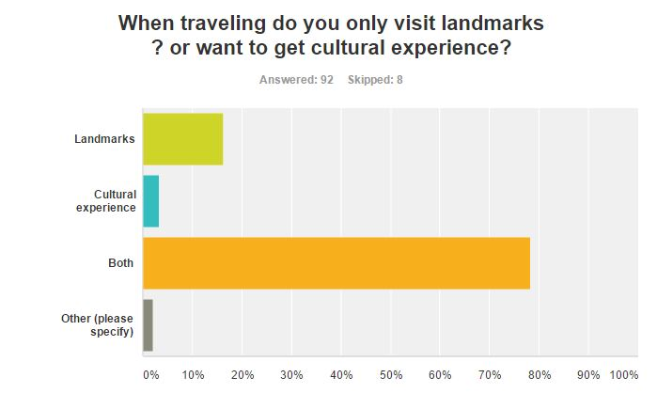

Figure 8: Survey response (a)

39 people said they were moderately satisfied with the prior online help and 29 people said they were very satisfied. 60.24% thought there is no need of additional technology that will help to get better experience.

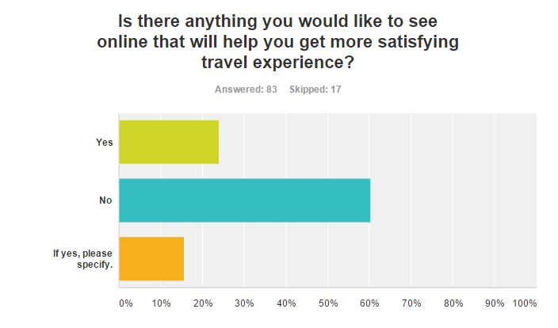

Figure 9: Survey response (b)

*Second Survey*

We used Google Forms to deliver survey questions to participants which explore people’s general travel reasons and habits, probe for motivating factors and learn about the role travel technology plays in making those decisions. We posted 16 questions to the travelers to mine the necessary data from their responses. For better understanding and analysis of data we restricted the number of responses to 24. 54.2% of the respondents were in the age group 36-45, 33.3% in 26-35 while 8.3% were in 18-25.The questions were semi-structured and few of them were open ended.

In response to our question ‘Have you ever been influenced by websites or advertisements on web to visit the place?’ we found 69.6% of people saying NO, which was a bit surprising because we thought technology has a huge impact on their decision (Figure 10). They also mentioned they are mostly influenced by google blog search, Norwegian, TripAdvisor, Goibibo etc.

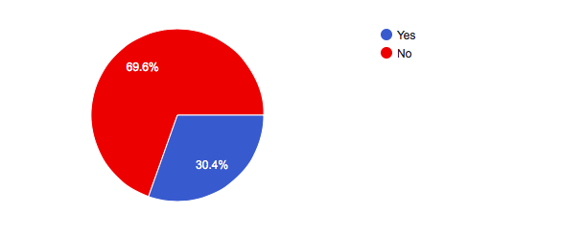

Figure 10: Survey response (c)

Later we wanted to understand if their purpose of visit was correlated to the interaction with technology. Turned out 91.7% go for family vacation, 37.5% go for adventure trips while 12.5% go for business. So the family vacation has a clear edge over the others. Later, we asked them what kind of experience they wanted to get in the first place. 20.8% said they wanted to visit landmarks, 8.3% said they wanted cultural experience of that place and 70.8% said they wanted both which is consistent with the interview response as well.

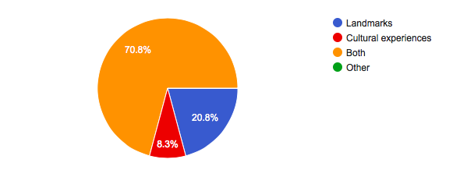

Figure 11: Survey response (d)

We discovered that people have an inclination towards the places they always wanted to visit rather than searching for that place online. As shown in Figure 12, more than 50% 'thought so. Only a few (33.3%) received friend suggestion and remaining others was not significant.

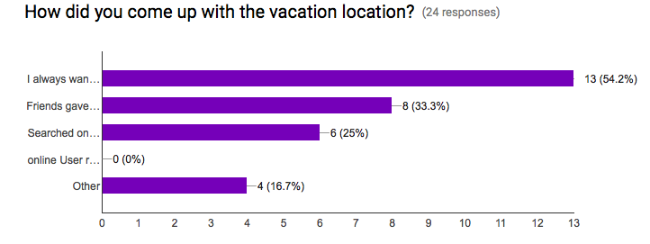

Figure 12: Survey response (e)

Then we asked them how they gather information about the place. A lion’s share (95.8%) goes to Google search rather than any particular website. A few others opted for phone calls and other websites. They mentioned Expedia, AAAWA as helpful websites. When asked about making travel arrangements, 70.8% said they use Google. The second majority was for Expedia (50%). 9 people prefer using TripAdvisor and Kayak while 8 people went for Hotels.com.

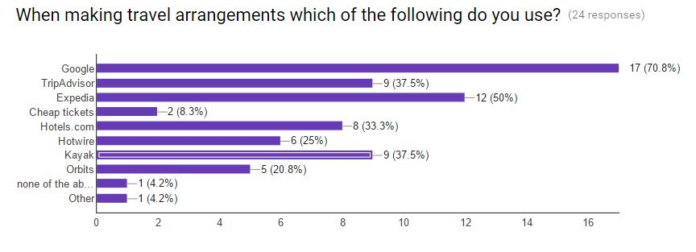

Figure 13: Survey response (f)

Later we wanted to know from them if there is anything they would like to see online that will help them to get more satisfying travel experience. Most of the travelers (71.4%) looked happy with the existing technology while 28.6% thinks augmentation is required.

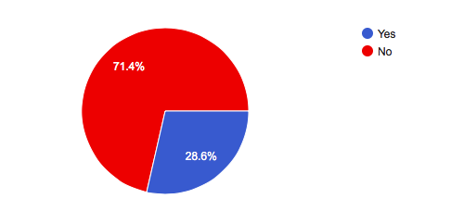

Figure 14: Survey response (g)

When being asked to mark their level of satisfaction with current technology in the scale of 1-5, 5 being strongly satisfied and 1 being strongly dissatisfied; 5 people marked 5, 16 marked 4 and 3 marked 3. So the average level of satisfaction was ~4.083 out of 5.

# FEEDBACK

Upon presenting our prototype before a class of Human-Computer Interaction students we received many interesting and encouraging feedbacks. We would like to quote few of those:

*“Good research with good collection of data”*

*“Would consulting with a travel agent on the design or refining of your ideas be helpful?”*

*“Really interesting synthesis of information. Prototype was something I'd really like to try out; I've seen sites that give you lists of things to do in your town, but nothing quite like this."*

*“Free family activities could be an interesting thing to add.”*

*“I like the idea of a family friendly travel search. The design looks nice and easy to pick up.”*

*“Very thoughtful prototype. I'm sure many families would enjoy a service like this. You might include an area for tips like on Yelp. Family friendly (casual, cheap) restaurants would also be good to include!”*

*“This is an interesting. I think it would be nice to take interaction design into consideration in the future improvement. Then we can get some real feedback from parents and kids, since different family may have different needs.”*

Besides there were some critics which will help us to revise our initial design and provide a better solution.

# Conclusion & future directive

In today’s modern world technology plays a vital role in every aspect of our life. So tourism and traveling is evolving according to the needs of modern travelers. Although the target population in our project thought there is no augmentation of existing technology is required, it is obvious that if there is any better and user-friendly technology available they will more than welcome it. Therefore we tried to provide a partial solution in form of Happy Travel search engine which facilitates family friendly vacation planning. In fine, we would like to admit that there might be some bias present in the data collection due to the lack of diversity so the sample was not representative of population. Also the design of prototype is not fully fledged and there might be some implementation issue in terms of incompatible data type etc. which we will try to overcome in future. However, the response that we got is pretty encouraging and we would love to incorporate their feedback i.e. using categorization system of search types in the history, merge multiple travel technology, discuss with travel agents for better design, incorporate cost with the planning in the website, extending the idea to support all kind of vacation planning etc.

# REFERENCES

1. Miguéns J, Baggio R, Costa C. Social media and tourism destinations: TripAdvisor case study. *Advances in Tourism Research*. (2008)
2. Gretzel, U. and Yoo, K.H. Use and Impact of Online Travel Reviews. *Information and Communication Technologies in Tourism 2008*, 35–46.
3. Aizenbud-Reshef, N., Barger, A., Guy, I., Dubinsky, Y., and Kremer-Davidson, S. Bon voyage. *Proceedings of the ACM 2012 conference on Computer Supported Cooperative Work - CSCW '12*
4. Cheverst, K., Davies, N., Mitchell, K., Friday, A., and Efstratiou, C. Developing a context-aware electronic tourist guide. *Proceedings of the SIGCHI conference on Human factors in computing systems - CHI '00*, .
5. Long, S., Kooper, R., Abowd, G.D., and Atkeson C.G. Rapid Prototyping of Mobile Context-Aware Applications: The Cyberguide Case Study, in *Proceedings of 2nd ACM International Conference on Mobile Computing* (Rye NY, 1996), ACM Press.
6. Broadbent, J., and Marti, P. Location Aware Mobile Interactive Guides: usability issues, in *Proceedings of the Fourth International Conference on Hypermedia and Interactivity in Museums (ICHIM97)* (Paris, 1997).
7. Vong, K. How Technology in Tourism is Taking Travel to the Next Level. *- TREND HUNTER PRO*. http://www.trendreports.com/article/technology-in-tourism.
8. Technology in tourism. http://dtxtq4w60xqpw.cloudfront.net/sites/all/files/pdf/unwtodigitalresources_volume1_techtourism_eng.pdf.